PHASE II: PROJECT PLANNING
Date | 06 November 2025
Team ID | NM2025TMID08793
Project Name | Lease Management
Maximum Marks | 4 Marks

Title: Project Planning for “Lease Management”

Objective
The Project Planning Phase defines the structural, security, and workflow foundation for the Lease Management system.
Its purpose is to analyse business requirements, identify lease-related entities, plan security levels, and create permission-based access for tenants, owners, and managers within Salesforce.
This phase also outlines logical relationships, user roles, and automation policies to ensure seamless management of property leasing operations.

Overview of the Planning Process
The planning phase involves four key components:
Step | Focus Area
1 | Defining Core Lease Entities
2 | Designing Data & Relationship Model
3 | User & Access Role Setup
4 | Timeline, Tools & Resource Planning
This ensures smooth lifecycle operations from property listing → leasing → payment → renewal/termination.

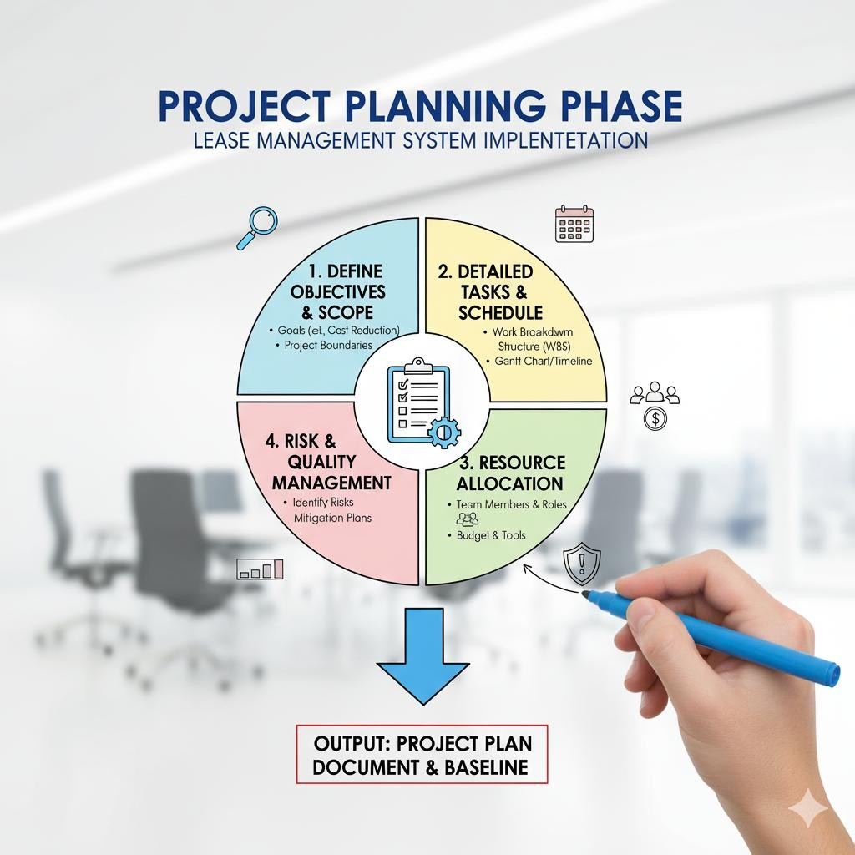

Core Entity Identification
The Lease Management application is organized around five main custom objects:
Object Name | Description | Relationships
Property | Represents a commercial or residential space available for lease. | Linked to Lease Agreement
Tenant | Represents the person/company leasing the property. | Linked to Lease Agreement  & Payment
Lease Agreement | Captures contract details (duration, rent, deposit). | Master-Detail with Payment
Payment | Tracks rent payments, due dates, and status. | Child of Lease Agreement
Maintenance  Request | Records service requests raised by tenants. | Linked to Property & Tenant
This structure enables monitoring of all lease activities from listing → agreement → rent → maintenance.

Relationship Strategy
Relationship  Type | Object Pair | Purpose
Master-Detail | Lease Agreement → Payment | Auto delete payment if lease is deleted
Lookup | Tenant → Property | Allows one tenant to lease multiple properties
Lookup | Maintenance Request →  Tenant | Allows tenants to raise service requests
Formula | Payment → Tenant | Pulls tenant name automatically from lease
This data architecture supports automation, dashboards, and record-level security.

Security and Profile Planning

Custom Profiles Created
Profile Name | Description | Access Level
Tenant Profile | For end users leasing the property | Read-only access on property, create maintenance request
Property Manager  Profile | Handles lease contracts & rent tracking | Full CRUD on lease related objects
System Admin | Default admin role | Full access

Public Groups
Public Group | Members | Purpose
Active Tenants | All tenant users | View their own agreements & payments
Property Managers | Admin-level users | Manage all property & lease data

Data Access and Sharing Rules
Rule Condition | Shared With | Purpose
Lease Status = "Active" | Tenant Group | Shows active lease only to assigned tenant
Payment Status = "Overdue" | Property Managers | Alerts for unpaid rent
Maintenance Urgency =  "High" | Property Managers  Group | Fast escalation of urgent issues
- Ensures tenants view only their own data
- Managers see full portfolio for decision-making

User Creation and Role Assignment

Procedure
- Setup → Users → New User
- Assign Salesforce Platform License for tenants
- Assign Salesforce License for managers
- Configure profile & public group membership
- Relate users to properties (via lookup/custom field)

User Hierarchy
Role | Assigned Profile | Group | Access Level
Property Manager | Property Manager Profile | Property Managers | Full Access
Tenant | Tenant Profile | Active Tenants | Limited Access
System Admin | Admin Profile | N/A | Full Control

Environment Setup and Configuration
Steps completed:
- Developer Edition created from Salesforce signup link
- Enabled Lightning App Experience
- Created app alias: Lease Management
- Added custom tabs for Property, Tenant, Lease Agreement, Payment
- Enabled Flow Builder, Reports, and Dashboard tools
- Configured branding & logo for property portal

Project Timeline and Resource Plan
Phase | Duration | Key Deliverables
Ideation | 2 Days | Problem Study, Use Cases
Planning | 3 Days | ERD, Profiles, Sharing Rules
Requirement Analysis | 4 Days | Field & Object Setup
Design & Implementation | 5 Days | Automation, UI Pages
Testing & Deployment | 2 Days | Validation, User Testing

Tools and Resources Used
Tool | Purpose
Lightning App Builder | UI Pages
Flow Builder | Rent automation & notifications
Apex Trigger | Auto-calc overdue days
Dashboard Builder | Rent due & occupancy reports
Schema Builder | Object mapping
SmartInternz | Submission & Mentorship

Expected Outcomes of the Planning Phase
- Data model finalized for property, leasing, payments
- User roles and sharing configured
- Secure Salesforce environment set up
- Automation and reporting structure defined
- Clear roadmap prepared for development & deployment

Summary
The Project Planning Phase creates the blueprint for implementing the Lease Management system. It ensures a structured, secure, and scalable approach to manage the entire leasing lifecycle using Salesforce.
By establishing roles, access models, and object relationships early, the project is ready to transition into Requirement Analysis and Implementation phases with clarity and confidence.

